**EXAMPLE 1 - INSTRUCTIONS**

**LOCK OUT/ TAG OUT POLICY**

**FILL-IN FORM**

**Requirements:**

Microsoft Word

Computer Skills: low to medium

**General Information:**

1. The LOTO Policy is a Microsoft Word document.
2. Insert company name, company logo, pictures, dates, YES/NO and other information easily with pre-set formatting (content control boxes).

**Instructions:**

1. Download forms from the website.
2. Save to your computer. Make sure file is saved as a Word document.
3. **ADD YOUR COMPANY NAME** – Click on the blue text and type in the company name. ***DO NOT hit enter***. Click outside the area to save the company name.
   1. This is a content control box. It is removed when the company name is entered.
4. **ADD YOUR COMPANY LOGO** to the LOTO Policy and **ADD PICTURES** in the document. Click on the picture in light blue shaded area. The picture folder will open. Select the picture desired (click on picture to highlight it) and click on “Insert” at the bottom. In the document click outside the picture area to “set” the picture in place. The picture is automatically sized to fit in the space available.
   1. This is a content control box.
   2. To Change the controls on the picture size – Click in the blue shaded area and “handles” will appear. Click and drag the handles to the picture size desired.
5. **ADD SPECIFIC INFORMATION** in policy – Click on blue text as indicated and type in requested information. DO NOT hit enter. Click outside the area to save typed text.
6. **ADD DATES** – Click on the blue text. Click on the down arrow. Select a date. Click outside the area to save the date.
   1. Change the date - click on the date, select new date, click outside area.
7. **ADD YES/NO** – Click on the box beside Yes or No and an X is inserted.
8. **ADD, CHANGE & DELETE content** on forms - Click & highlight text to change or delete
9. **PRINT** form when completed.

**LOTO Policy Example 1 Instructions, page 2**

1. **Content Control Boxes**
   1. **Delete –** Click on the blue text or for pictures the blue shaded area. A tab will appear. Click on the tab and hit the delete button on the keyboard.

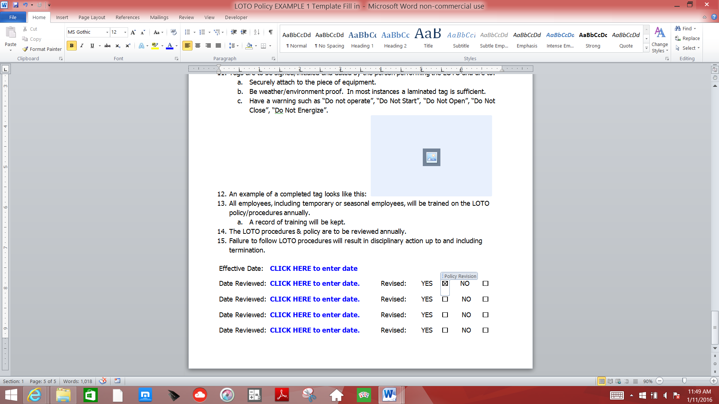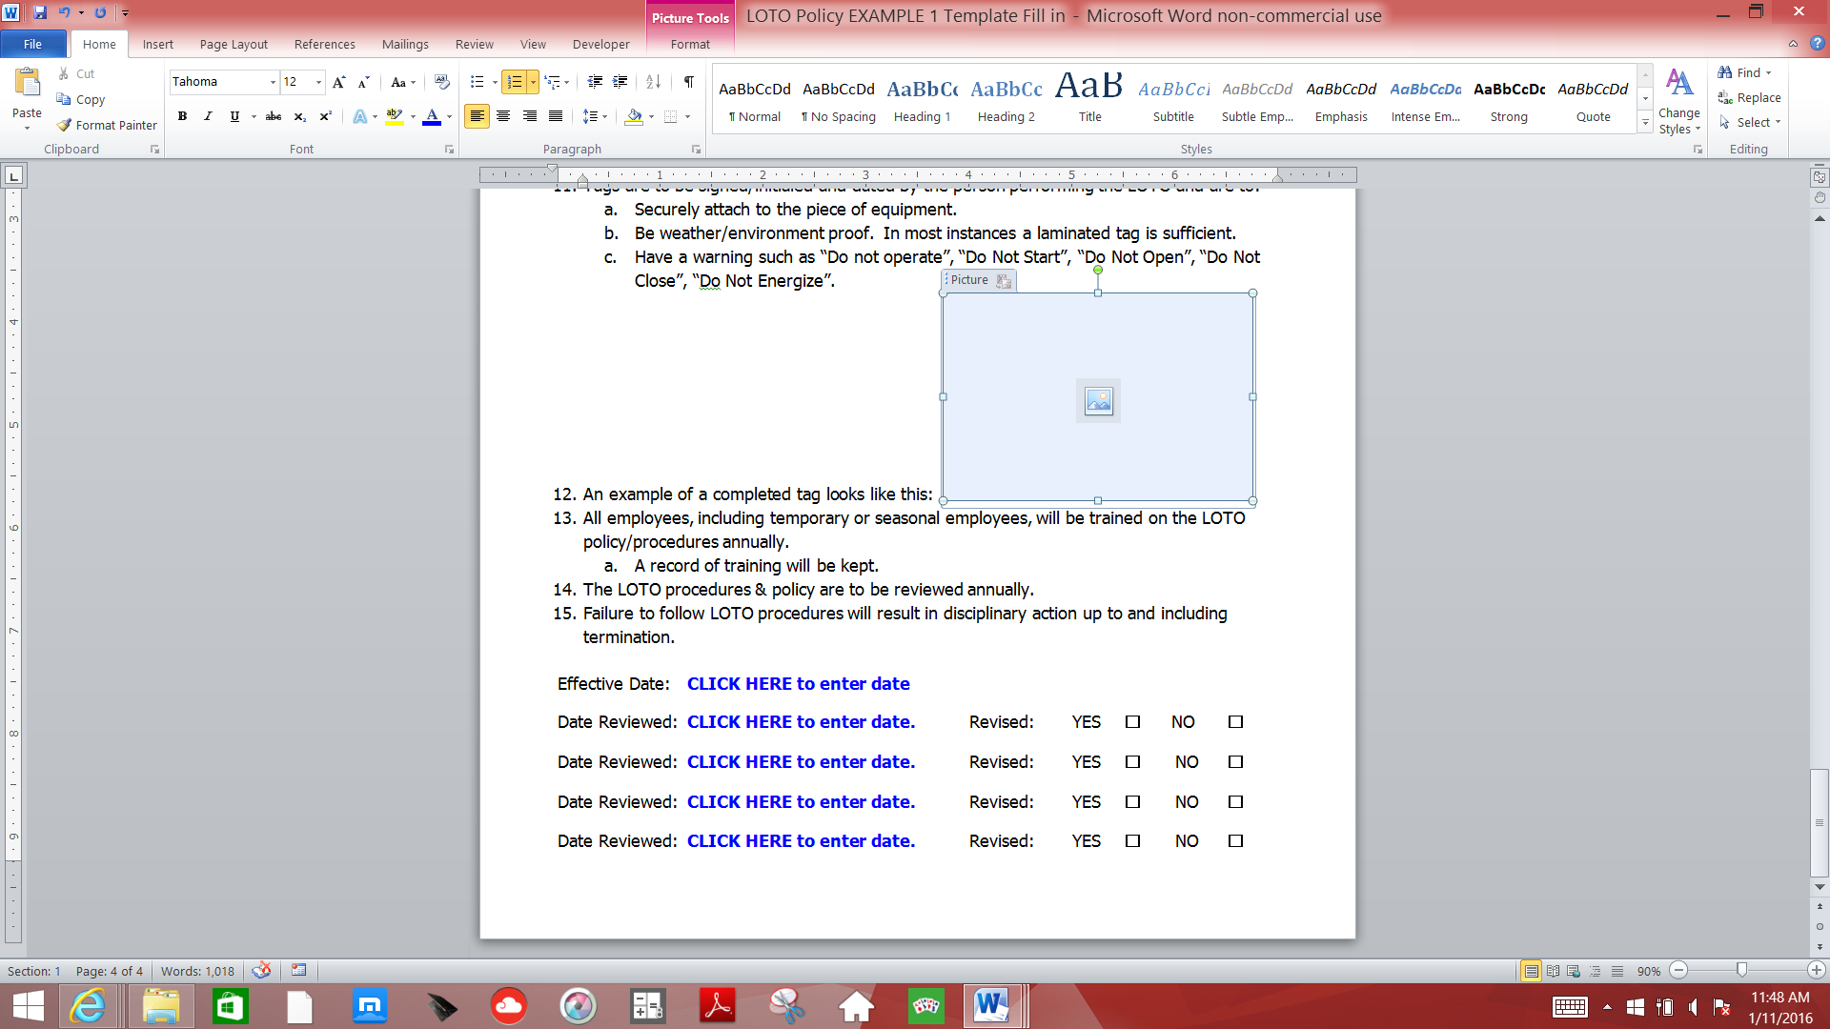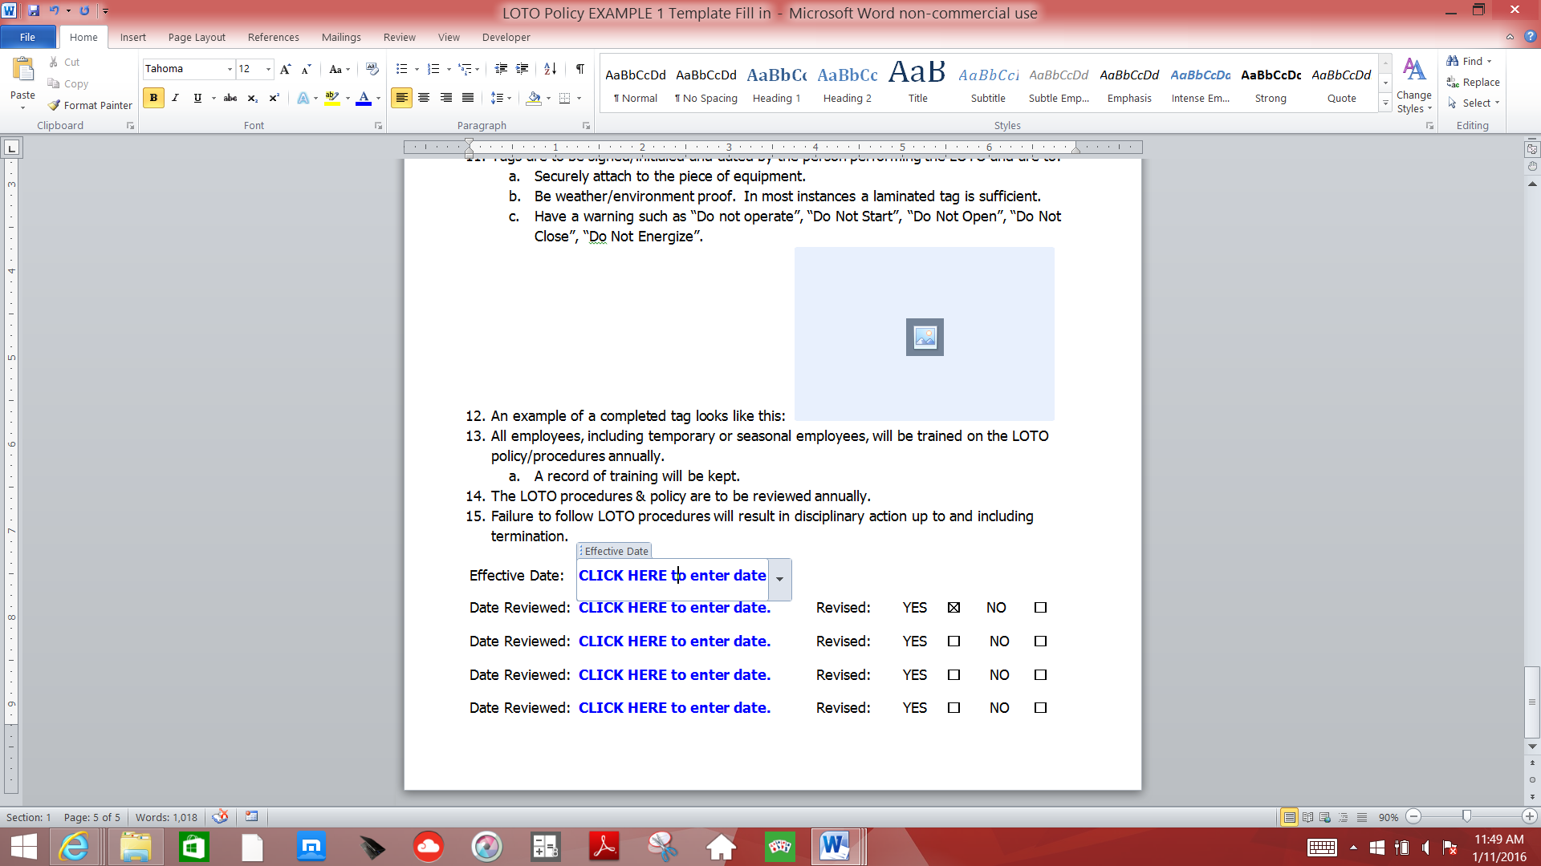

* 1. **Changes** - To make other changes to any content control box the Developer menu tab is needed. If the Developer tab is not on the menu bar go to File, choose Options, select Customize Ribbons. Select Main tabs in the upper right drop down menu and then select Developer in the middle right box and click OK. Making Changes to content control boxes requires a medium skill level. Use the HELP feature if unfamiliar with the Developer functions.

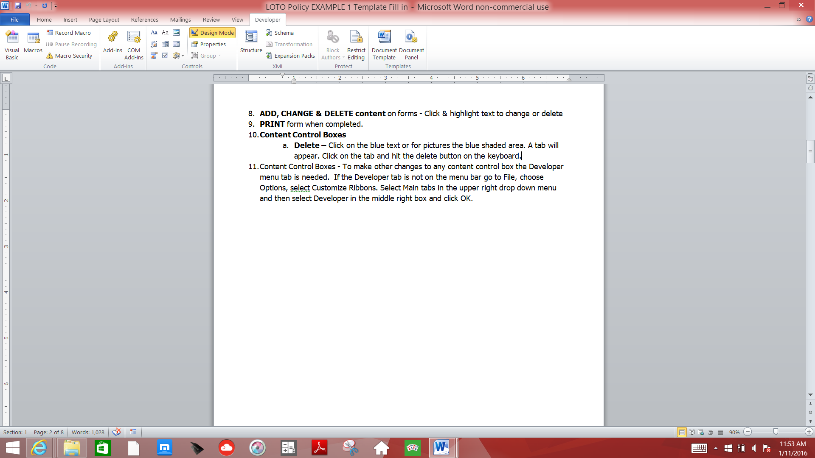



**CLICK HERE & type Company Name.**

**LOCK OUT/ TAG OUT POLICY**

1. LOTO will be performed:
   1. Before servicing or maintenance of equipment.
   2. Prior to entry into ANY grain bin or grain storage structure.
   3. Prior to entry into any area or structure where operating equipment would pose a hazard.
2. All energy sources for each piece of equipment will be shut down and the energy source isolated, locked out and tagged out according to its procedure.
3. The performance of LOTO will be done according to recognized safe procedures.
   1. Reference: Typical minimal lockout procedure – 29 CFR 1910.147 App. A
4. LOTO will be performed only by those persons trained and authorized to do so. At **CLICK HERE & type Company Name**. the following persons are authorized to perform LOTO:
   1. **CLICK HERE & type authorized LOTO position and/or person’s name.**
   2. **CLICK HERE & type authorized LOTO position and/or person’s name.**
   3. **CLICK HERE & type authorized LOTO position and/or person’s name.**
   4. **CLICK HERE & type authorized LOTO position and/or person’s name.**
   5. **CLICK HERE & type authorized LOTO position and/or person’s name.**
5. There will be one lock for each person working on the equipment or involved in the bin entry or involved in any activity where Lock out/Tag out procedures are to be completed.
6. For entry into any grain bin or grain storage structure or any area or structure where operating equipment would pose a hazard– the entrant is required to place his lock on the lockout device(s) prior to bin entry – no exceptions.
7. Locks used for LOTO may only have one (1) key per lock.
   1. Keys should be in the possession of the person who placed the lock.
8. Locks & Tags are to be removed **ONLY** by the person who placed it on the equipment.
   1. If a lock needs to be removed by another person ONLY the manager should do so or a trained person at the direction of the manager.
   2. The procedures for Emergency Lock Removal are to be followed.
9. Locks are to be easily identifiable and only be used for energy isolation purposes. Locks are to be standardized within a facility by color, shape, size, type, etc and be durable and substantial.
10. To correctly identify a LOTO lock, this facility will use a **CLICK HERE & type description (type, color, etc.).** lock.
11. Tags are to be signed/initialed and dated by the person performing the LOTO and are to:
    1. Securely attach to the piece of equipment.
    2. Be weather/environment proof. In most instances a laminated tag is sufficient.
    3. Have a warning such as “Do not operate”, “Do Not Start”, “Do Not Open”, “Do Not Close”, “Do Not Energize”.



1. An example of this facility’s Lock and a completed tag looks like this:

 

1. All employees, including temporary or seasonal employees, will be trained on the LOTO policy/procedures annually.
   1. A record of training will be kept.
2. The LOTO procedures & policy are to be reviewed annually.
3. ***Failure to follow LOTO procedures will result in disciplinary action up to and including termination***.

Effective Date:  **CLICK HERE to enter date**

Date Reviewed: **CLICK HERE to enter date.** Revised: YES  NO

Date Reviewed: **CLICK HERE to enter date.** Revised: YES  NO

Date Reviewed: **CLICK HERE to enter date.** Revised: YES  NO

Date Reviewed: **CLICK HERE to enter date.** Revised: YES  NO